**Researching Principles of the** **Virtual and Augment Reality Applications for**

**Academic Education**

**Contents**

1． Introduction

1.1 Background and research environment

1.2 Objectives and scope

1.3 Research process and contribution of research papers

1.4 Dissertation structure

2. Conceptual Background of Related knowledges

2.1 Related concepts (AR/VR/MR…)

2.2 Overview of Augment/ Virtual reality Education applications(Shortcomings)！

2.3 HCI (Human- Computer Interaction) and Interaction Design

3. How to Design and Develop a Virtual and Augment Reality Application for Education?

3.1 Educational AR/VR application characteristic

3.2 Investigating requirements for Educational AR/VR application

3.3 Educational AR/VR application Shortcomings and solutions ***

3.4 Interaction Designs in the VR/AR applications

3.4.1 Human-Centered Design for VR/AR

3.4.2 Shortcomings and solutions

3.4.3 User interface design

3.4 How to Improve UX?

4. Developing 3 AR&VR applications cases

4.1 A Board game design for Math

4.1.1 Introduce and Design principle

4.1.2 Project Implementation(Programing)

4.2 VR Art Show

4.2.1 Introduce and Design principle

4.2.2 Project Implementation(Programing)

4.3 AR&VR Chemistry Lab

4.3.1 Introduce and Design principle (LeapMotion and Oculus HMD)

4.3.2 Project Implementation(Programing)

4.4 Evaluate and Conclusion

4.4.1 Evaluation system

1, price-performance ratio (hardware, cost , portability…)

2, UX (diagram, interview)

3, Educational effect (questionnaire survey)

4.4.2 Evaluations for the 3 cases

5. Implementation Results analysis

5.1 [Objective for implementation](javascript:;)

5.2 Evaluations’ Conclusion

6. Conclusions and discussion

6.1 Conclusions

6.2 Limitations

6.3 Future directions in Augment and Virtual reality ---expanding applications ---Apply AR/VR mode in Other subjects (Match, physics, art, biology, geography…)

1． Introduction

1.1 Background and research environment

[VR is quickly becoming a vital component of how we learn](https://techcrunch.com/2016/01/23/when-virtual-reality-meets-education/). Virtual reality is one such technology, and it’s making inroads into every aspect of education. From the top levels of higher education to amateur video tutorials,

1.2 Objectives and scope

1.3 Research process and contribution of research papers

1.4 Dissertation structure

2. Conceptual Background of Related knowledges

2.1 Related concepts (AR/VR/MR…)

2.2 Overview of Augment/ Virtual reality Education applications(Shortcomings)！

VR technology indeed has successful application cases in educational, here are some in the K12 classroom (K12 is the North American designation for primary and secondary education. The expression is a shortening of Kindergarten through 12th grade, the first and last grades of free education in the United States and English Canada)

2.3 HCI (Human- Computer Interaction) and Interaction Design

3. How to Design and Develop a Virtual and Augment Reality Application for Education?

3.1 Educational AR/VR application characteristic

3.2 Investigating requirements for Educational AR/VR application

3.3 Educational AR/VR application Shortcomings and solutions ***

3.4 Interaction Designs in the VR/AR applications

3.4.1 Human-Centered Design for VR/AR

3.4.2 Shortcomings and solutions

3.4.3 User interface design

3.4 How to Improve UX?

4. Developing 3 AR&VR applications cases

4.1 A Board game design for Math

AR is the integration of digital information with the user's environment in real time [1]. AR is developed based on VR, however, unlike virtual reality, which creates a totally artificial environment, augmented reality uses the existing environment and overlays new information on top of it. In this project, we made a board game that can allow multiplayers to play in a combination of realistic and virtual space. In this Board Game, there are 3 characters with different colors and several buttons to control the characters.

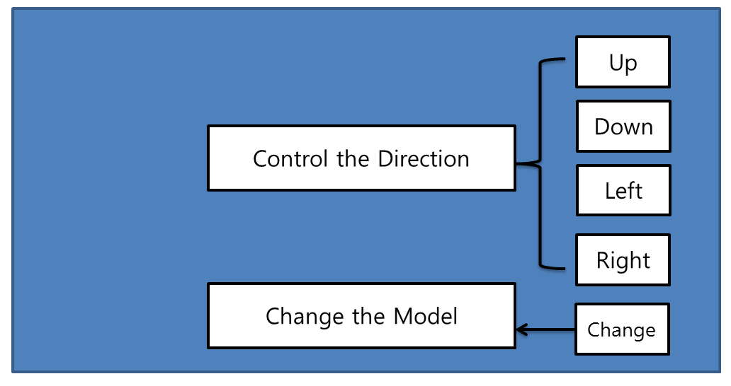

Fig.1 the board game Flowchart

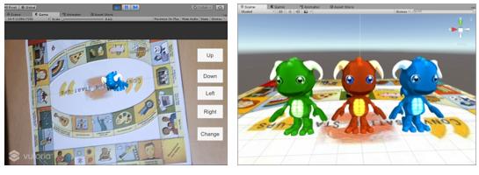

(a) Beginning the game (Game Scene) (b) Game Models

Fig.2 Result of designed Game

4.1.1 Introduce and Design principle

4.1.2 Project Implementation(Programing)

4.2 VR Art Show

4.2.1 Introduce and Design principle

4.2.2 Project Implementation(Programing)

4.3 AR&VR Chemistry Lab

The conventional education system modes are primarily passive or receptive learning style, many teachers think that students learned the experimental principle and method is important and enough, so they no need to do many experiments, according to our research, present teaching methods have limits shows as below: First: Lack of motivation and of activity, students are shown the experiments results instead of probing the results. Second: Temporal and spatial constraints; students cannot do the experiments anytime and anywhere for the limits of objective conditions, and cannot repeat the experiment steps. Third: Wasted reagents and danger, some of the reagents are dangerous, therefore many practices are requisite before using the real ones. In this way can save the reagents and lessen the danger. To break the limits as we build up this application, use this can let the users practice the experiments wherever and whenever they need in a more active and probing learning way, and can also can save the reagents and lessen the danger probability. Meanwhile compare to the 2d chemistry applications it guarantees the immersion almost alike the real world, in addition we also design a feature that users can see the microcosmic things like molecular structure using mark AR. All the solutions are confirmed Improved learning efficiency.

4.3.1 Introduce and Design principle (LeapMotion and Oculus HMD)

4.3.2 Project Implementation(Programing)

4.4 Evaluate and Conclusion

4.4.1 Evaluation system

1, price-performance ratio (hardware, cost , portability…)

2, UX (diagram, interview)

3, Educational effect (questionnaire survey)

4.4.2 Evaluations for the 3 cases

5. Implementation Results analysis

5.1 [Objective for implementation](javascript:;)

5.2 Evaluations’ Conclusion

6. Conclusions and discussion

6.1 Conclusions

6.2 Limitations

“我的问题始终是：虚拟现实与教育片到底有什么不同？”教育科技博客作者及撰稿人奥黛丽·沃特斯（Audrey Watters）说道，“我确实担心，人们会越来越多地在模拟或虚拟现实技术的伪装下使用教育片代替学生的外出实地考察以及其他线下的丰富活动。”[2]

VR头显和手套可能要花费数百美元，这使得大多数学校系统很难提供通用的接入服务。虽然价格较低的产品——比如售价15美元的谷歌Cardboard——可以方便地安装在智能手机上，但这些 VR盒子 往往无法提供较好的体验。事实上，批评人士认为，学校现在所谓的虚拟现实或增强现实应用，并不是通过VR头显而是在笔记本电脑、平板电脑和手机上进行的。换句话说，很多人仍然不确定VR到底是什么，而且这个定义还在不断地演变。

6.3 Future directions in Augment and Virtual reality ---expanding applications ---Apply AR/VR mode in Other subjects (Match, physics, art, biology, geography…)

References

1. AR, http://whatis.techtarget.com/definition/augmented-reality-AR, [Article(CrossRef Link)](http://whatis.techtarget.com/definition/augmented-reality-AR)
2. http://vr.99.com/news/07192017/001616650.shtml